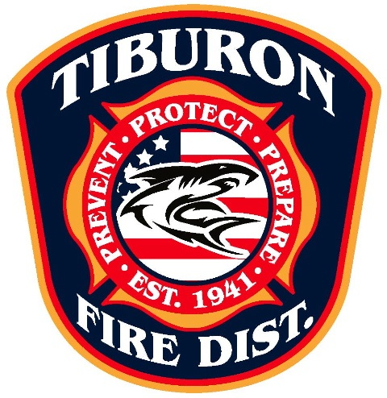

Director Robert Miller has served on the TFPD Board since 2006. Dr. Miller is a graduate of the United States Naval Academy and graduated from Cornell Medical College with an MD degree. He has been a resident of Tiburon since 1986. Robert is a Physician in an active medical practice and brings 30 years of medical experience to the Board. He is also quite passionate about disaster preparedness and is certified in the Get Ready program. As well as being Red Cross certified for disaster triage, he also serves as a Block Captain to coordinate preparedness in neighborhoods. (Term: 2015-2019)

